Report for the period 1. October 2018 to 1. October 2019
WP#4: INDUSTRIAL KELP FACILITIES AS ARTIFICIAL KELP FORESTS
By Trine Bekkby¹, Ragnhild Grimm Torstensen^{1,2}, Lars Andreas Grünfeld^{1,2}, Hartvig Christie¹, Eli Rinde¹, Luiza Neves³ and Kasper Hancke¹
¹ Norwegian Institute for Water Research, NIVA
² Department of Biosciences, University of Oslo
³ Seaweed Energy Solutions (SES)

The aims of WP4
The aims of WP4 is to 1) determine the role of kelp cultivation facilities as “artificial forests”, 2) estimate the role of cultivated kelp as medium for distribution of unwanted species and 3) evaluate the role of cultivated kelp on natural kelp communities.
WP4 tasks are:
- T4.1. Abundance, species composition and function of kelp associated algae and invertebrates
- T4.2. Distribution of unwanted and red-listed species
- T4.3. Genetic diversity in natural and cultivated kelp

Tasks performed
Two field work campaigns were conducted along the east side of Frøya, Trøndelag, on the Midwest coast of Norway in 2019, one in April (just before harvesting of the kelp in the farm) and one in September (after harvesting). Figure 1 shows a map with the location of the stations.

Field and lab work April 2019
In order to assess the potential role of kelp farms as an “artificial forest”, species of algae (associated with the kelp), invertebrates (using fauna traps) and fish (using fish nets) were collected in the farm and in natural kelp forests before kelp harvesting. In order to find out if the kelp farm houses kelp species specific communities, species were collected both in the Saccharina latissima and Alaria esculenta (both in the farm and in the wild), as both species were cultivated. In order to assess the effect of longer growth period, species were collected in S. latissima seeded in both September 2018 and in January 2019. Species were also collected in the Laminaria hyperborea forests in order to see if this natural kelp forest, which dominates the area and surround the kelp farm, impacts the species composition in the farm. Species were collected in the water masses as a control. The species collected in April were identified in the lab in June 2019

Field and lab work September 2019
In order to see if the species composition found in the farm is associated to the kelp growing there or just an effect of the infrastructure of ropes, lines and buoys (covering an area of approx. 250 x 300 m), species of invertebrates and fish were also collected after kelp harvesting. The species collected in September are now identified in the lab and all groups of species (from both the April and September survey) are counted and weighed.

Preliminary results
Figure 2 shows the work carried out in WP4 and Figure 3 shows some preliminary results from the April survey (before harvesting). These results show that there is a big difference in number of species between the kelp in the farm and the natural kelp forests, for all kelp species, with the kelp forests having more species. If we look at the kelp plant associated species (i.e. not the fauna traps), then the S. latissima seeded in September (growing for 7 months in the farm) had more species than the plants seeded in January (growing for only 3 months in the farm). However, the fauna traps (collecting the mobile fauna) did not show the same pattern. Note that these are just preliminary results from the April (before harvesting) survey.

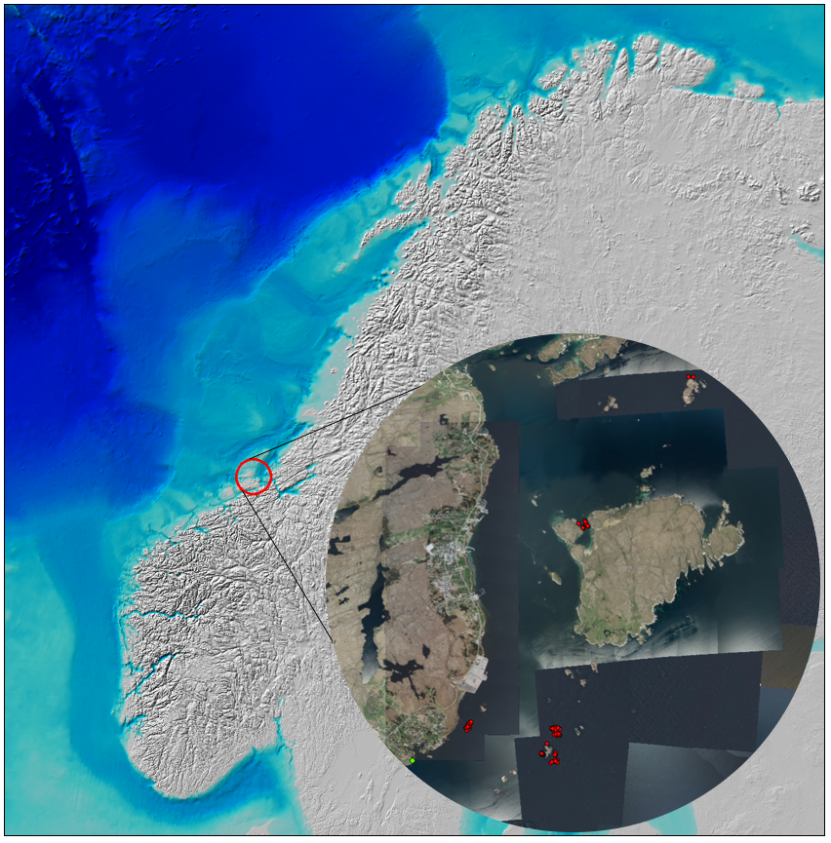
Figure 1. A map with the location of the stations at Sistranda Frøya (east side, 63°43’31’’N 8°50′2″E), Trøndelag, on the Midwest coast of Norway. The study area is located in within the red circle on the overview map and the individua stations (red dots) are shows on the detailed map. The green dot in the southwest corner of the detailed map shows the site of field base. Source of overview map: www.gebco.net

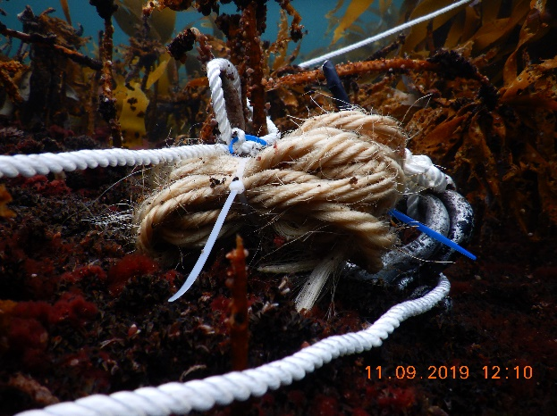  A. Fauna traps deployed in the kelp forest. Foto: E. Rinde, NIVA. | 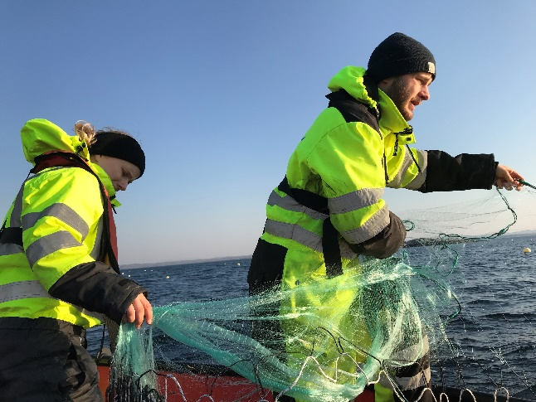  B. Fish nets deployed (by Ragnhild G. Torstensen and Lars A. Grünfeld), Foto: T. Bekkby, NIVA
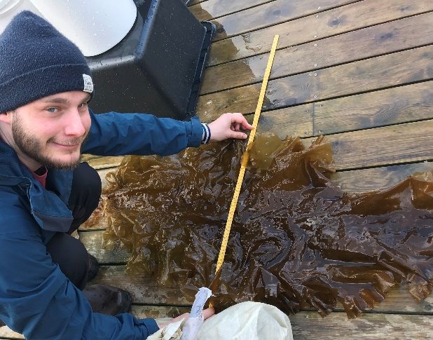  C. Measuring kelp (Lars A. Grünfeld), Foto: T. Bekkby, NIVA | 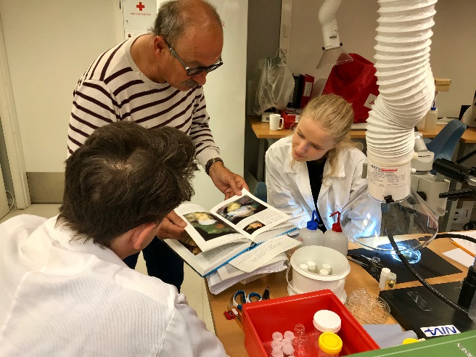  D. Identifying invertebrate species in the lab (Ragnhild G. Torstensen, Lars A. Grünfeld and Hartvig Christie), Foto: T. Bekkby, NIVA
Figure 2. Illustration of the work carried out in WP4, Fauna traps (A) and fish nets (B) put out in the kelp farm, natural kelp forests and water masses (for control). Kelp plants were measured in the field (C) and the invertebrate species were identified in the NIVA lab (D).

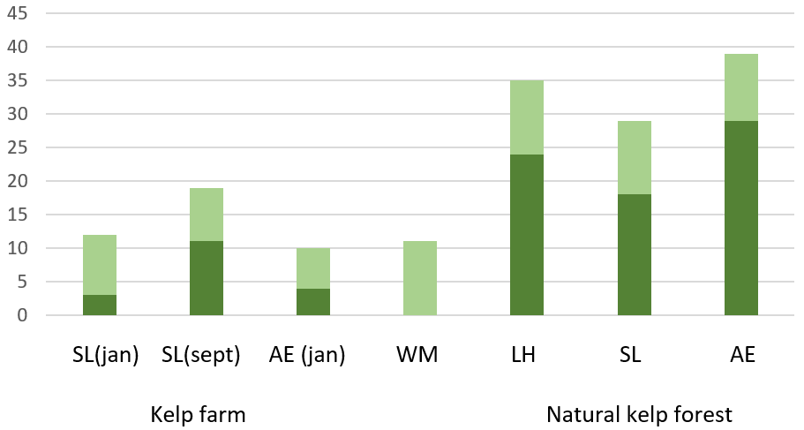
Figure 3. The number of species found in the kelp farm and the natural kelp forests in April (before harvesting), both in Saccharina latissima (SL), Alaria esculenta (AE) and Laminaria hyperborea (LH, is not farmed). The S. latissima was seeded in both January and in September, the A. esculenta only in January. Species were collected in the water masses (WM) for control. Dark green=kelp plants, light green: fauna traps.

Plans for the next phase
The statistical analyses of the data collected in the field will start 01.10.2019, after the laboratory work is finished. These analyses will be conducted by the students, under the supervision of NIVA project members. Functional groups will be defined, and diversity indices will be calculated. The statistical analyses on abundance, species composition and functional traits will finish by 01.04.2020. This will be part of two Master theses, a collaboration between NIVA, SES and the University of Oslo. Based on the analyses and the two Master theses, a paper will be written on the abundance, biodiversity and function of species associated with kelp cultivation facilities compared to natural kelp forests; incl. the potential of kelp farms as nesting ground for unwanted and red-listed species (first WP4 deliverable, from T4.1 and T4.2).

The work on the genetic diversity in cultivated and natural kelp forests has just started and will continue in Autumn 2019 and early Spring 2020. This work will be assessed by the use of existing knowledge, literature surveys and models on spreading and suitable areas for kelp growth. The task will be carried out in collaboration with the project MACROSEA. This Task (T4.3) will provide the second WP4 deliverable, a report on up-to-date knowledge of genetic variation in kelp and assessment of potential risks imposed on natural kelp populations.

The third WP4 deliverable will combine all results from WP4 in a baseline description of the current knowledge and gaps with a perspective for future studies.

Deviations from the original plan
- According to the plan, field work was supposed to take place at two different kelp cultivation facilities, both SES and Hortimare. However, the work fitted better with the ongoing work and seeding and harvesting plans of SES and Hortimare was therefore not included.
- According to the plan, field work was supposed to take place in May (prior to harvesting) and August (after harvest). However, as the harvesting of the farm by SES took place already in April, the field work had to start earlier. This might impact the results. Also, for practical and logistic reasons, the Autumn survey was postponed from August to September.
- Tasks 4.1 and 4.2 were scheduled to be finished by September 2019. However, as the last field campaign ended 12.09.2019 the laboratory work is still ongoing. The new deadline for the lab work is set to 01.10.2019 and the statistical analyses will start immediately after that. These analyses will be conducted by the students, under the supervision of NIVA project members. The statistical analyses will finish by 01.04.2020. Task 4.3 will finish in 2020 as planned.

Publication and communication
Publication and communication from WP4
- 4 tweets on @TrineBekkby and @NIVAkelp on field activities and observations during the September field campaign
- 7 Tweets on @TrineBekkby, @NIVAkelp and @kasper_hancke on field activities and observations during the April field campaign

Publication and communication related to KELPPRO in general
- Gundersen, Andersen GS, Bekkby T, Christie HC, Fagerli CW, Filbee-Dexter K, Frigstad H, Gitmark JK, Hancke K, Kile MR, Moy SR, Ramirez-Llodra E, Rinde E, Tveiten LA, Walday MG. 2018. Tare i tiden. NIVA institute seminar 01.12.2018.
- Hancke K, Gundersen H, Bekkby T. KELPPRO - Seaweed farming, good or bad news to the coast and society? 2018. Poster at the Norwegian Research Council MARINFORSK conference 24-25.10.2018.

